North-East town council facing £300,000 bill to settle clerk's bullying claim
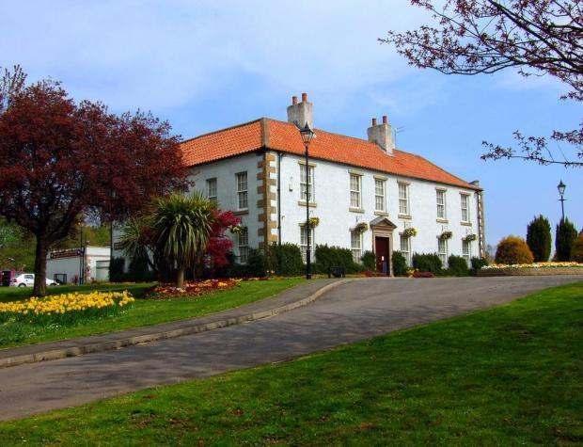
Peterlee Town Council, which is based at Shotton Hall, pictured, has been described as "shambolic" by one of its own councillors amid allegations of fraud, rows among councillors and demands for answers from electors. Pic: Dominic Wade.
Exclusive by Joe Willis, Regional Chief Reporter / 04:02 Monday 30 November 2015 / Peterlee
Share
A NORTH-East town council is facing a £300,000 bill to pay off an employee who accused two councillors of bullying.
Peterlee Town Council has been described as "shambolic" by one of its own members amid allegations of fraud, rows among councillors and demands for answers from voters.
An employment tribunal was due to take place this week after town council clerk Jane Russell claimed she had been bullied by two Labour members.
However, The Northern Echo understands the clerk has been offered more than £200,000 to settle the claim out of court.
A source has revealed that the authority faces legal costs on top of this which could reach £100,000.
The councillors at the centre of the accusations by Ms Russell are Labour members Mandy Thompson and former mayor Bill Jeffrey.
Cllr Thompson last night denied she had done anything wrong, saying she had "never bullied anyone in her life".
The councillor said the fall-out began after she raised concerns about the clerk's pay.
Ms Russell went off sick in February 2013.
She was paid her full salary for six months, but Cllr Thompson asked questions after the authority continued to pay the full £60,000 salary when she remained off work.
As well as seeking answers from the council, she went to Durham Police claiming documents had been fraudulently falsified at the authority.
The force investigated but did not press charges against anyone.
It is understood the police involvement was one of the issues raised by the clerk in her grievance against the council.
In response to the claim the council appointed an independent panel to examine her complaint. This panel concluded Ms Russell had been bullied.
The clerk then began legal proceedings against the authority.
Cllr Thompson, however, appointed her own barrister who claimed the panel was "wholly unlawful".
The councillor said: "I was trying to protect the public purse by examining the clerk's pay but it's been at considerable cost to myself.
"The councillors were unable to comprehend that the independent panel was unlawful and now it has agreed to pay out all this money - it's a disgrace."
Cllr Jeffrey said he could not comment in detail but said Cllr Thompson had his full support.
Another councillor who asked not to be named said the authority was a "shambles", but said many councillors blamed the two Labour members for the predicament.
Ian Stanley, from Oakerside, in Peterlee, is one of several residents who have been asking questions of the council.
He has used Freedom of Information powers to find out why the council tax precept was increased by 7.7 per cent this year when the authority had reserves of more than £1m.
"They haven't provided any business case for the council tax rise which I think is indefensible. The problem is that there is nobody who has authority over town councils and they can do what they want."
Share article
Peterlee Town Council and its mayor, Mary Cartwright, from the North East Party, declined to comment.
The Northern Echo was unable to contact Ms Russell.

